**Introduction:**

**What is an Integration Solution?**

Its about connecting apps and data sources together in enterprise world. This connection can be connecting different systems to share data or integrate different software tools to automate processes. The goal is to make it easy for different systems and apps to communicate and share the information.

What is iPaaS?

Its integration Platform as a Service, which is a type of integration solution that is delivered by the cloud(serverless) which can connect cloud based and on premise apps.

Basics of Azure Integration Services:

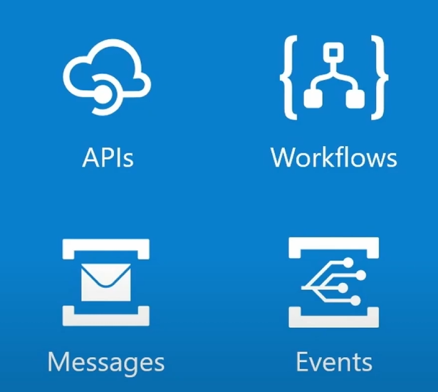

**The 4 main components of Azure Integration Service:**

**Azure Logic Apps:** A cloud service that helps you automate workflows and integrate your apps, data, systems, and services across different environments without writing code.

**Azure Service Bus:** A fully managed enterprise integration message broker service that provides reliable message queuing and durable publish/subscribe messaging.

**Azure API Management:** A fully managed service that enables organizations to publish, secure, transform, maintain, and monitor APIs.

**Azure Event Grid:** A fully managed event routing service that simplifies event-based programming by providing a uniform event consumption model and reliable event delivery at scale.

**Azure Integration Resource Group(RG):**

1. Create a resource. Then create the first resource which will be named “Processing-Order” and follow the initialization for those 5 components:

* Storage account
* API Management service
* APP Service plan
* Function App
* Service Bus Namespace

For example(Storage account):

Storage account name is globally unique, thus, I had to change the name to something like “jbarak”. After the creation of all other resources mentioned above, the source group should look like:

Note: the APP Service plan components requires a special pay-on-the-go subscription.

**Step 1A – Create the “queue polling” event process:**

1. Inside the source group click on create and browse for “logic app”.
2. Then choose “logic app” and leave all as it, create.
3. Click “go to resource”.
4. First configuration:

When a HTTP request is received

1. Then:

Azure 🡪 ValidateOrders

Choose “body” and then POST method. This will ensure that the HTTP request is validated based on its body content, so that isValid flag will turn to True. This should look like:

The schema will be auto created.

1. Once we receive the HTTP request, we need to validate it based on the flag. So the next step should be:

Control 🡪 Condition 🡪 insert function on body::isValid flag

Should look like this:

Set then value of the flag to True.

1. If True:

Then the service bus will poll the request and code 200 will be generated:

To link the Service Bus we should go to the Service Bus component:

Resource Group 🡪 Shared access policies 🡪 choose the SB 🡪 copy the “primary connection string”

Go back and paste in the Service Bus Connection String:

And create the connection to the service bus. Choose the orders queue:

And select the body to place the whole message as it is into the service bus:

Then the response will be the action:

1. If False:

Then return error 400 and save the process:

1. Now we can save the whole process and test and run the trigger.

**Step 1B – Create the “process message” event:**

Now lets build the second message that picks the message from the queue and processes it:

1. Create “logic app” process.
2. Go to resource and press the “when message received…” and follow the steps below:

Note: change to 1 minute pulling and rename the queue to “orders”.

1. Then the process itself:

The method by which the message will be processed is POST.

1. Lets expose our integration solution as RESTful API in more secure manner:

And change the name of the URL.

1. Now the API has been created. Click it and then test.

Done